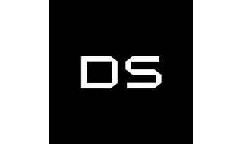



Explore

[**DataStax** is a company that empowers generative AI applications with real-time, scalable data and production-ready vector data tools, seamlessly integrating with developers’ stacks of choice1](https://www.datastax.com/)[2](https://www.imda.gov.sg/resources/innovative-tech-companies-directory/datastax).

Here are **five reference links** where you can learn more about DataStax and its offerings:

1. [**DataStax Official Website**](https://www.datastax.com/): Explore DataStax’s one-stop Generative AI stack for building production-ready apps[1](https://www.datastax.com/).
2. [**DataStax Reviews on G2**](https://www.g2.com/products/datastax/reviews): Discover details, pricing, and features of DataStax from user reviews[3](https://www.g2.com/products/datastax/reviews).
3. [**DataStax on IMDA**](https://www.imda.gov.sg/resources/innovative-tech-companies-directory/datastax): Learn how DataStax enables enterprises to mobilize real-time data for smart AI applications at unlimited scale[2](https://www.imda.gov.sg/resources/innovative-tech-companies-directory/datastax).
4. [**DataStax Company Overview**](https://www.datastax.com/company): Understand how DataStax focuses on delivering powerful, accurate Generative AI applications to production with zero delay and zero operations[4](https://www.datastax.com/company).
5. [**DataStax Astra DB Documentation**](https://www.datastax.com/company): Dive into tutorials, examples, and best practices for Generative AI and RAG (Relevance, Availability, and Generative AI) using DataStax Astra DB[1](https://www.datastax.com/).

Feel free to explore these resources to enhance your understanding of DataStax and its role in the tech industry! 🚀